

Submitted By:
Muhammad Ahmed Subhani
SU92 – BSSEM – S25 – 018
Section: 4-A

Submitted To:
Sir Rasikh Ali

Department of Software Engineering
Superior University, Lahore
Table of Contents
Leaf Evaluation 3
MiniMax 3
1. Program: 3
2. Working: 4
Alpha Beta Pruning 7

LAB 5

Leaf Evaluation

MiniMax

Program:

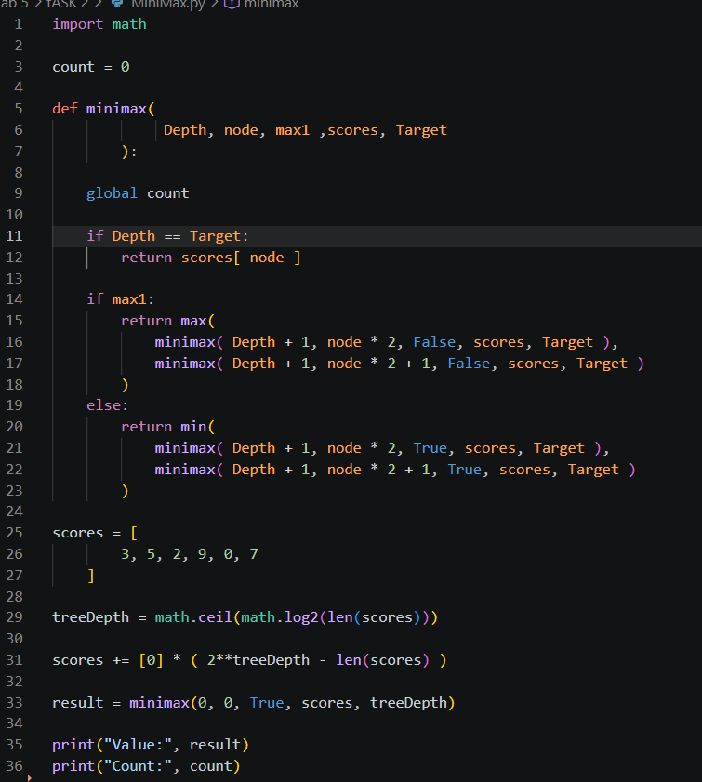

Working:
import math
Just imported a library of math for math.ceil(math.log2)
count = 0
Global variable to count increment.
def minimax(Depth, node, max1 ,scores, Target):
Created a function with name minimax having 5 parameters.
Depth: Current depth level of the tree.
Node: Current node of the tree.
Max1: A bool var. If True Max Turns if False Min Turns.
Scores: Value taken from the pdf program.
Target: The goal that is meant to be reached.
if Depth == Target:
return scores[ node ]
Checks whether the depth has reached the Target or not. If yes then it stops recursing ansd returns the node index from the scores. Hence, scores[ node ].
if max1:
return max(
minimax( Depth + 1, node * 2, False, scores, Target ),
minimax( Depth + 1, node * 2 + 1, False, scores, Target )
)
else:
return min(
minimax( Depth + 1, node * 2, True, scores, Target ),
minimax( Depth + 1, node * 2 + 1, True, scores, Target )
)
If max 1 is True these set of statement are executed if False else statement is executed. True makes maximizer to max the score. False makes the minimum to min the score.
In True statement:
minimax( Depth + 1, node * 2, False, scores, Target ),
minimax( Depth + 1, node * 2 + 1, False, scores, Target )
Depth + 1, node * 2 Looks at Depth 1 and looks at left we know it because node * 2 looks at left
Depth + 1, node * 2 + 1 Also looks at the Depth 1 but looks at the right child because node * 2 + 1.
In False statement:
minimax( Depth + 1, node * 2, False, scores, Target ),
minimax( Depth + 1, node * 2 + 1, False, scores, Target )
Depth + 1, node * 2 Looks at Depth 1 and looks at left we know it because node * 2 looks at left
Depth + 1, node * 2 + 1 Also looks at the Depth 1 but looks at the right child because node * 2 + 1.
scores = [
3, 5, 2, 9, 0, 7
]
Default Values from pdf.
treeDepth = math.ceil(math.log2(len(scores)))

len(scores) = Length of the scores which is 6.
Math.log(6) = 3 = Taking the base 2 log of 6
Math.ceil(3) = Converts the float to int by slicing the number after . decimal.
treeDepth = 3. Hence, The 3 Layers in diagram.
scores += [0] * ( 2**treeDepth - len(scores) )

In previous task we added two 0 at the end of the scores. We are doing thatb in programming by writing this.
2**treeDepth - len(scores) = 8 – 6 = 2
Hence,
The two 0 at the end is formed.
Updated score:
[ 3, 5, 2, 9, 0, 7, 0, 0 ]
result = minimax(0, 0, True, scores, treeDepth)

Calls the function while giving them arguments like:
Depth = 0
Node = 0
Max1 = True
Target = 3
Scores = [ 3, 5, 2, 9, 0, 7, 0, 0 ]

Alpha Beta Pruning
Only the difference between the programs is being written other then that every thing is same.
def alphabeta(depth, index, max1, scores, target, alpha, beta):
The only addition is change of function name and addition of 2 more arguments alpha and beta.
float('-inf'), float('inf')
ALPHA
float('-inf') : This is the top most highest score that a maxi can set.
BETA
float('inf') : This is the top most lowest score that a mini can set.
for i in range(2):
value = max(
value,
alphabeta(depth + 1, index * 2 + i, False,
scores, target, alpha, beta)
)

alpha = max(alpha, value)

if alpha >= beta:
break
This is the loop of Max because if it becomes True this is executed.
Depth + 1 = goes 1 level deeper.
index * 2 + I = checks index of the each child.
False: Next turn is of Min.
alpha = max(alpha, value)

Updating alpha value.

if alpha >= beta:
break
This is pruning.

